Understanding Call Numbers

Have you ever wondered how library books are assigned their places on the shelves? Did you know that the call number -- the number placed on the spine of the book -- is a code which provides valuable information about the book?
This page is an introduction to understanding and using library call numbers.
If you'd like a printed copy of this information, ask your librarian for Pathfinder 6.

What are call numbers for?
Each book in the library has a unique call number. A call number is like an address: it tells us where the book is located in the library.
Call numbers appear
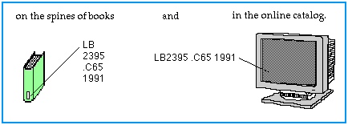
Note that the same call number can be written from top-to-bottom, or left-to-right.

This system uses a combination of letters and numbers to arrange materials by subjects.

Reading Call Numbers
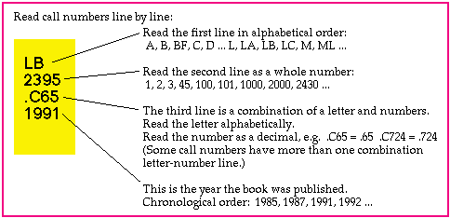

Putting Call Numbers in Shelf Order
To understand how call numbers are put in order in Library of Congress Classification, again look at each section of the call number.
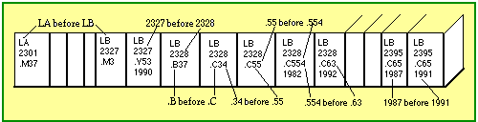

What does the call number mean?
Remember that Library of Congress Classification arranges materials by subjects.
- The first sections of the call number represent the subject of the book.
- The letter-and-decimal section of the call number often represents the author's last name.
- And, as you recall, the last section of a call number is often the date of publication.
example:
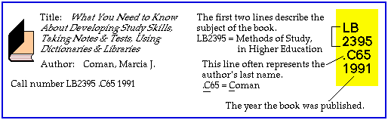

Why is this important to know?
Because books are classified by subject, you can often find several helpful books on the same shelf, or nearby. For example, within the same call number LB2395, there are other guides for college study.
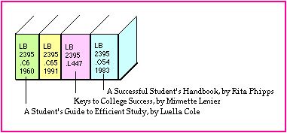
Since Library of Congress Classification arranges materials by subjects, knowing the letter(s) for your subject area gives you a place to start browsing the shelves. Which letters represent your subject? View the Library of Congress Classification Table.

Location Prefixes
When a call number looks like the examples above, (e.g. LB2395 .C65 1991), the book is shelved on the second floor of HCC Library. Some call numbers, however, are preceded by a location prefix.
example:
Ref AG243 .G87 1992
The Ref prefix indicates that this book is shelved in the Reference Collection.
Location prefixes mean that book is shelved in a special place, and may have loan restrictions. HCC Library uses the following location prefixes:
Prefix | Collection | SBCS Library Location | Loan Period
[Blank] | Circulating Collection | MAIN | 7-day loan
HawPac |  |  | 7-day loan
Oversize | Oversize -- a big book! |  | 7-day loan
Popular | Popular -- mostly fiction, such as mystery, sci-fi, and romance |  | 7-day loan
Ref | Reference Collection |  | Library-use only
Tech Ref | Automobile Technical Collection |  | Library-use only
Dinosaur | Dinosaur Collection |  | 7-day loan
Ocean | Ocean Collection |  | Library-use only
Reserve | Reserve Book set aside for a class |  | Set by instructor
Tele | Telecourse videotape |  | Overnight
For more information about call numbers and finding library materials, ask your librarian.

